The Immune System: A Play in Two Acts
Your task: Develop a play that illustrates one of the following: the humoral response or the cell-mediated response.

Your play should begin with an invading pathogen and illustrate the following:
- A specific pathogen.
- A specific point of entry.
- A specific route by which the pathogen can spread.
- The existing nonspecific barriers to the pathogen.
- The nonspecific response to the pathogen.
- The action of either the humoral or cell-mediated immune system – or BOTH!
- The method by which the immune system retains knowledge of the pathogen.

Your play should demonstrate your knowledge and understanding of the immune system and interactions between the major cells and molecules in the immune system.
To assist you in your efforts, begin by reading through the attached “cast of characters” which details how the immune system functions.

You will have three days in class to complete your task – but I encourage you to do outside reading and research to supplement this time in class.

Your grade will come from your script – which should be e-mailed to me at biowithoutwalls@gmail.com and your in-class presentation. This is worth a quiz grade!

You will be graded on the clarity, accuracy, and depth of research your play shows, as well as for having a smooth presentation. You are encouraged to use props and/or costumes when appropriate.

These plays will be due in class on Friday, March 12, 2010.

The Immune System - Overview

Introduction

We are surrounded by billions of bacteria and viruses. To many of them, a human being is like a walking smorgasbord, offering nearly limitless resources that they can use for energy and reproduction. Luckily for us, getting into the human body is not an easy task!

From the point of view of these tiny organisms, a human is a bit like a fortress. The skin is thick and very hard to penetrate. In addition, the skin also produces a variety of substances that are harmful to invaders. Openings such as the eyes, nose, and mouth are protected by fluids or sticky mucus that capture harmful attackers. The respiratory tract also has mechanical defenses in the form of cilia, tiny hairs that remove particles. Intruders that get as far as the stomach are up against a sea of stomach acid that kills most of them.
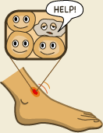
But in spite of our fantastic defenses, hostile invaders still manage to get through. Some enter along with our food, while others may sneak in via the nose. And, as we all know, many things can break through our skin. In everyday life we often receive cuts or scrapes, and every time this happens we face the risk of a full-scale invasion from bacteria or viruses. What is the magic, then, that keeps us healthy most of the time?
When we receive a cut, and when invaders enter the body, cells are destroyed. The dying cells trigger an automatic response called inflammation, which includes dilated blood vessels and increased blood flow. An inflammation is the body's equivalent to a burglar alarm. Once it goes off, it draws defensive cells to the damaged area in great numbers. Increased blood flow helps defensive cells reach the place where they're needed. It also accounts for the redness and swelling that occur.

Immune Cells: The Defense
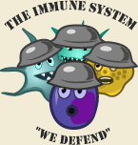

The defensive cells are more commonly known as immune cells. They are part of a highly effective defense force called the immune system. The cells of the immune system work together with different proteins to seek out and destroy anything foreign or dangerous that enters our body. It takes some time for the immune cells to be activated - but once they're operating at full strength, there are very few hostile organisms that stand a chance.

Immune cells are white blood cells produced in huge quantities in the bone marrow. There are a wide variety of immune cells, each with its own strengths and weaknesses. Some seek out and devour invading organisms, while others destroy infected or mutated body cells. Yet another type has the ability to release special proteins called antibodies that mark intruders for destruction by other cells.

But the really cool thing about the immune system is that it has the ability to "remember" enemies that it has fought in the past. If the immune system detects a "registered" invader, it will strike much more quickly and more fiercely against it. As a result, an invader that tries to attack the body a second time will most likely be wiped out before there are any symptoms of disease. When this happens, we say that the body has become immune.

Bacteria and Viruses: Our Main Enemies

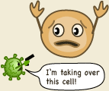
Now that you know a bit about our defenses, let's take a closer look at our primary enemies. Bacteria and viruses are the organisms most often responsible for attacking our bodies.
Most bacteria are free living, while others live in or on other organisms, including humans. Unfortunately, many bacteria that have human hosts produce toxins (poisons) that damage the body. Not all bacteria are harmful, though. Some are neutral and many are even desirable as they fulfill important functions in the body.

Bacteria are complete organisms that reproduce by cell division. Viruses, on the other hand, cannot reproduce on their own. They need a host cell. They hijack body cells of humans or other species, and trick them into producing new viruses that can then invade other cells. Frequently, the host cell is destroyed during the process.

Pathogens and Antigens


In daily life we might speak of viruses, bacteria, and toxins. However, when reading about the immune system you’ll often come across the words antigen and pathogen. An antigen is a foreign substance that triggers a reaction from the immune system. Antigens are often found on the surfaces of bacteria and viruses. A pathogen is a microscopic organism that causes sickness. Hostile bacteria and viruses are examples of pathogens.

The Immune System - in More Detail

Introduction

The immune system is one of nature's more fascinating inventions. With ease, it protects us against billions of bacteria, viruses, and other parasites. Most of us never reflect upon the fact that while we hang out with our friends, watch TV, or go to school, inside our bodies, our immune system is constantly on the alert, attacking at the first sign of an invasion by harmful organisms.

The immune system is very complex. It's made up of several types of cells and proteins that have different jobs to do in fighting foreign invaders. In this section, we'll take a look at the parts of the immune system in some detail.

The Complement System
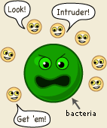
The first part of the immune system that meets invaders such as bacteria is a group of proteins called the complement system. These proteins flow freely in the blood and can quickly reach the site of an invasion where they can react directly with antigens - molecules that the body recognizes as foreign substances. When activated, the complement proteins can:
- Trigger inflammation.
- Attract eater cells such as macrophages to the area.
- Coat intruders so that eater cells are more likely to devour them.
- Kill intruders by forming a membrane attack complex – basically punching holes in the invading cells’ membranes to lyse (destroy) the cell and cause cell death.

Phagocytes
This is a group of immune cells specialized in finding and "eating" bacteria, viruses, and dead or injured body cells. There are three main types, the granulocyte, the macrophage, and the dendritic cell. There are other types not listed here, including mast cells and natural killer cells.


The granulocytes often take the first stand during an infection. They attack any invaders in large numbers, and "eat" until they die. The pus in an infected wound consists chiefly of dead granulocytes. A small part of the granulocyte community is specialized in attacking larger parasites such as worms.
These include netrophils, eosinphils, and basophils.

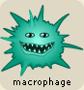
The macrophages ("big eaters") are slower to respond to invaders than the granulocytes, but they are larger, live longer, and have far greater capacities. Macrophages also play a key part in alerting the rest of the immune system of invaders. Macrophages start out as white blood cells called monocytes. Monocytes that leave the blood stream turn into macrophages.


The dendritic cells are "eater" cells and devour intruders, like the granulocytes and the macrophages. And like the macrophages, the dendritic cells help with the activation of the rest of the immune system. They are also capable of filtering body fluids to clear them of foreign organisms and particles.

The mast cells are involved in the inflammatory response and release histamines that cause capillaries to swell and become “leaky,” leading to the red appearance of inflamed areas.

Natural Killer Cells release perforin protein that puts holes into the membranes of pathogenic cells. This lyses or ruptures the cells, causing apoptosis – cell death!

Lymphocytes - T cells and B cells
White blood cells called lymphocytes originate in the bone marrow but migrate to parts of the lymphatic system such as the lymph nodes, spleen, and thymus. There are two main types of lymphatic cells, T cells and B cells. The lymphatic system also involves a transportation system - lymph vessels - for transportation and storage of lymphocyte cells within the body. The lymphatic system feeds cells into the body and filters out dead cells and invading organisms such as bacteria.
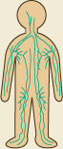
On the surface of each lymphatic cell are receptors that enable them to recognize foreign substances. These receptors are very specialized - each can match only one specific antigen.
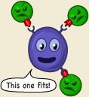
To understand the receptors, think of a hand that can only grab one specific item. Imagine that your hands could only pick up apples. You would be a true apple-picking champion - but you wouldn't be able to pick up anything else.
In your body, each single receptor equals a hand in search of its "apple." The lymphocyte cells travel through your body until they find an antigen of the right size and shape to match their specific receptors. It might seem limiting that the receptors of each lymphocyte cell can only match one specific type of antigen, but the body makes up for this by producing so many different lymphocyte cells that the immune system can recognize nearly all invaders.

T cells
T cells come in two different types: helper cells and killer cells. They are named T cells after the thymus, an organ situated under the breastbone. T cells are produced in the bone marrow and later move to the thymus where they mature.


Helper T cells are the major driving force and the main regulators of the immune defense. Their primary task is to activate B cells and killer T cells. However, the helper T cells themselves must be activated. This happens when a macrophage or dendritic cell, which has eaten an invader, travels to the nearest lymph node to present information about the captured pathogen. The phagocyte displays an antigen fragment from the invader on its own surface, a process called antigen presentation. The cell that presents an antigen is known as an antigen-presenting cell (NPC). When the receptor of a helper T cell recognizes the antigen, the T cell is activated. Once activated, helper T cells start to divide and to produce proteins that activate B and T cells as well as other immune cells.

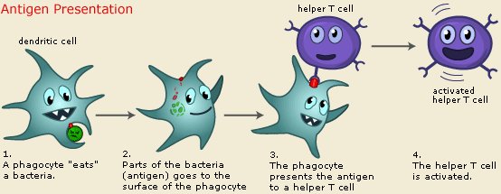

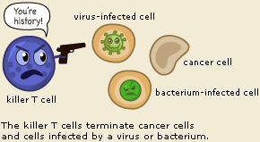
The killer T cell is specialized in attacking cells of the body infected by viruses and sometimes also by bacteria. It can also attack cancer cells. The killer T cell has receptors that are used to search each cell that it meets. If a cell is infected, it is swiftly killed. Infected cells are recognized because tiny traces of the intruder, antigen, can be found on their surface.

B Cells
The B lymphocyte cell searches for antigen matching its receptors. If it finds such antigen it connects to it, and inside the B cell a triggering signal is set off. The B cell now needs proteins produced by helper T cells to become fully activated. When this happens, the B cell starts to divide to produce clones of itself. During this process, two new cell types are created, plasma cells and B memory cells.
The plasma cell is specialized in producing a specific protein, called an antibody that will respond to the same antigen that matched the B cell receptor. Antibodies are released from the plasma cell so that they can seek out intruders and help destroy them. Plasma cells produce antibodies at an amazing rate and can release tens of thousands of antibodies per second.
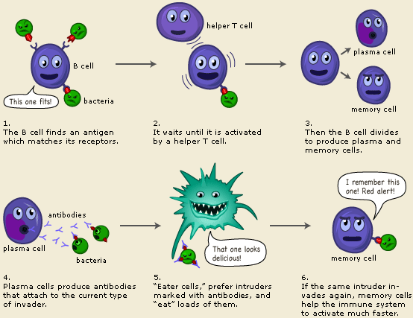
When the Y-shaped antibody finds a matching antigen, it attaches to it. The attached antibodies serve as an appetizing coating for eater cells such as the macrophage. Antibodies also neutralize toxins and incapacitate viruses, preventing them from infecting new cells. Each branch of the Y-shaped antibody can bind to a different antigen, so while one branch binds to an antigen on one cell, the other branch could bind to another cell - in this way pathogens are gathered into larger groups that are easier for phagocyte cells to devour.

Bacteria and other pathogens covered with antibodies are also more likely to be attacked by the proteins from the complement system.

The Memory Cells are the second cell type produced by the division of B cells. These cells have a prolonged life span and can thereby "remember" specific intruders. T cells can also produce memory cells with an even longer life span than B memory cells. The second time an intruder tries to invade the body, B and T memory cells help the immune system to activate much faster. The invaders are wiped out before the infected human feels any symptoms. The body has achieved immunity against the invader.

Conclusion
Although rather long and complex, our presentation is just a glimpse of the immune system and the intricate ways in which its various parts interact. Immunity is a fascinating subject that still conceals many secrets. When the immune system is fully understood, it will most likely hold the key to ridding humankind of many of its most feared diseases.

