Platyhelminthes
- Bilateral symmetry
- No body cavity: acoelomate (spaces between internal organs are filled by loose parenchyma)
- Triploblastic
- Displays cephalization
- Embryonic development: protostome
- Digestive system incomplete (a mouth but no anus-a single opening ingests food and eliminates waste)
- Nervous system is comprised of a pair of anterior ganglia or a nerve ring connected to 1-3 pairs of longitudinal nerve chords with transverse commissures
- Excretory system: consists of flame cells (specialized cells that remove waste) and their associated ducts
- No circulatory system
- Major Events: Flatworms have the ability to regenerate. If a worm is cut in half, or in many pieces, each piece grows into a new flatworm.

Examples:
Freshwater Planarian
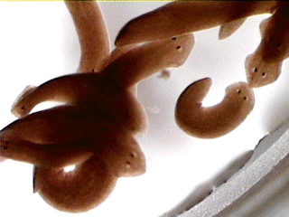
http://www.biologyjunction.com/unsegmented_worm_notes_b1.htm
Tapeworm
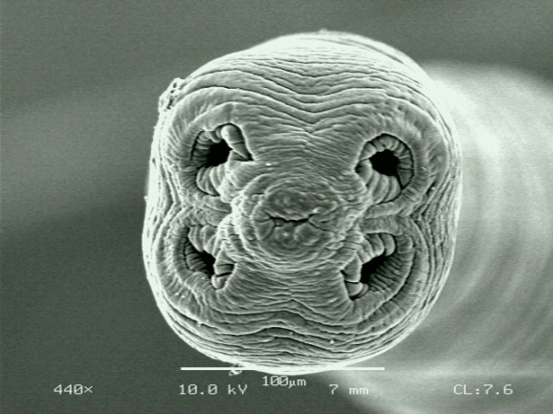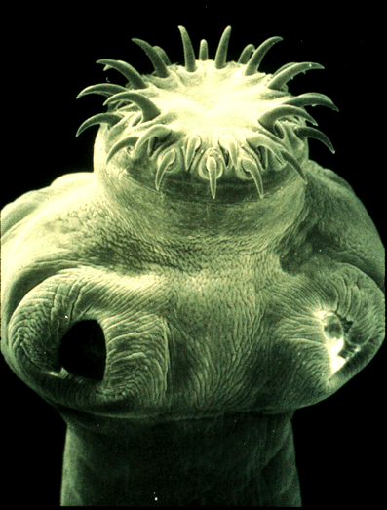
http://www.mansfield.ohio-state.edu/~sabedon/black11.htm

Resources:
http://animaldiversity.ummz.umich.edu/site/accounts/information/Platyhelminthes.html
http://www.ucmp.berkeley.edu/platyhelminthes/platyhelminthes.html

Nematoda
- Bilaterally symmetrical
- Body cavity (pseudocoelomate)
- Tribloblastic
- Displays cephalization
- Embryonic development: protostome
- Digestive tract is complete: anterior mouth, muscular and glandular pharynx (esophagus), long, straight midgut (intestine), rectum, and ventral anus
- Nervous System: four nerves run the length of the body and a pharyngeal nerve ring serves as the brain
- Excretory System: no specific organs involved; waste is excreted in the form of ammonia through the body wall
- No circulatory system

Examples:
Pin Worms
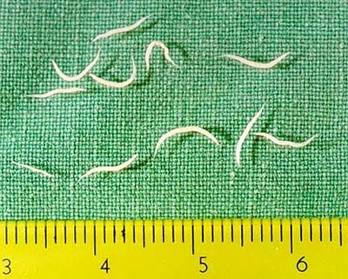
http://dj003.k12.sd.us/SCHOOL%20NOTES/chapter_10.htm
Ascaris suum
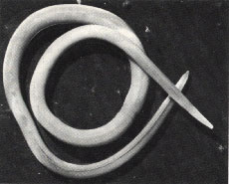
http://www.nematodes.org/nembase4/tribe.php?inf=5&tribe=867

Resources:
http://www.ucmp.berkeley.edu/phyla/ecdysozoa/nematoda.html
http://nematode.unl.edu/

Amphibians
- Body structure: Amphibians have a head, trunk, front legs, and hind legs. Some also have tails. They also have smooth, silky skin usually covered in mucus secretions.
- Gas Exchange: diffusion through skin
- 3-chambered heart
- Ectotherm (cold-blooded)
- Amphibians practice both internal and external fertilization. Many frogs and toads lay eggs and fertilization occurs externally. Salamanders and caecilians use internal fertilization.
- Most amphibians develop externally in soft eggs
- Subgroups: frogs, toads, salamanders, newts, and caecilians
- Major Events: Many amphibians begin life as tadpoles. As they grow, legs develop, tail size is reduces, gills disappear, and some amphibians leave the water.

Examples:
Strawberry Poison Dart Frog
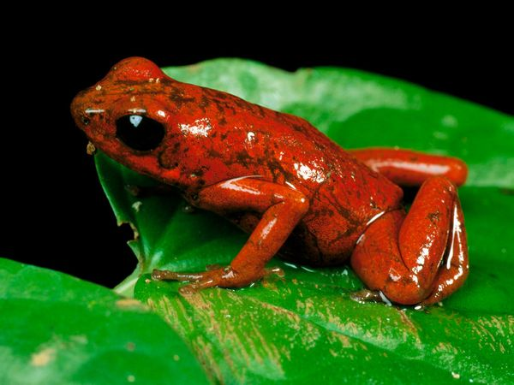
http://animals.nationalgeographic.com/animals/photos/poison-dart-frogs/#2467_600x450.jpg
Blue-spotted Salamander (Ambystoma laterale )
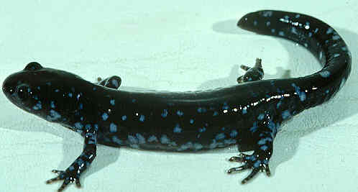
http://www.cortland.edu/herp/keys/salapix.htm
Resources:
http://www.ucmp.berkeley.edu/vertebrates/tetrapods/amphibintro.html

